[](http://aws.amazon.com/)

Amazon Web Services

Data Engineering Immersion Day

Database Migration Services Student Setup Instructions

Jun 2019

Table of Contents

Introduction 2

Create the Student Environment 3

Appendix: AWS CloudFormation Template 4

# Introduction

This guide helps students set up the pre-environment for the AWS Database Migration Service (AWS DMS) lab.

AWS DMS required source and destination as shown below:

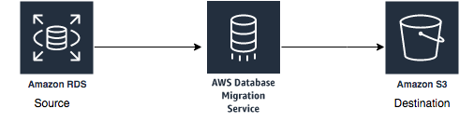

Your instructor will provide you source database details during main lab to configure source endpoint. If you ran instructor lab to setup your own instance of Postgre database then use instance endpoint from instructor lab.

In this lab, you will complete the following pre-requisite using AWS CloudFormation template deployment:

1. Create required VPC setup for AWS DMS instance.
2. Create Amazon S3 bucket for destination end point configuration.
3. Create required Amazon S3 bucket policy to put data by AWS DMS service.
4. Create Glue Service Role to use in later hands-on workshop.

# Create the Student Environment

**\*\*\*Make sure you select the us-east-1 (Virginia) region\*\*\***

1. Sign in to the AWS console where you will host the student environment.
2. Navigate to the AWS CloudFormation page.
3. Launch a new stack with the AWS CloudFormation template DMSlab_student_CFN.json provided with your lab package. Alternatively, You can follow instruction in Appendix : AWS CloudFormation Template to create AWS CloudFormation template for this lab.

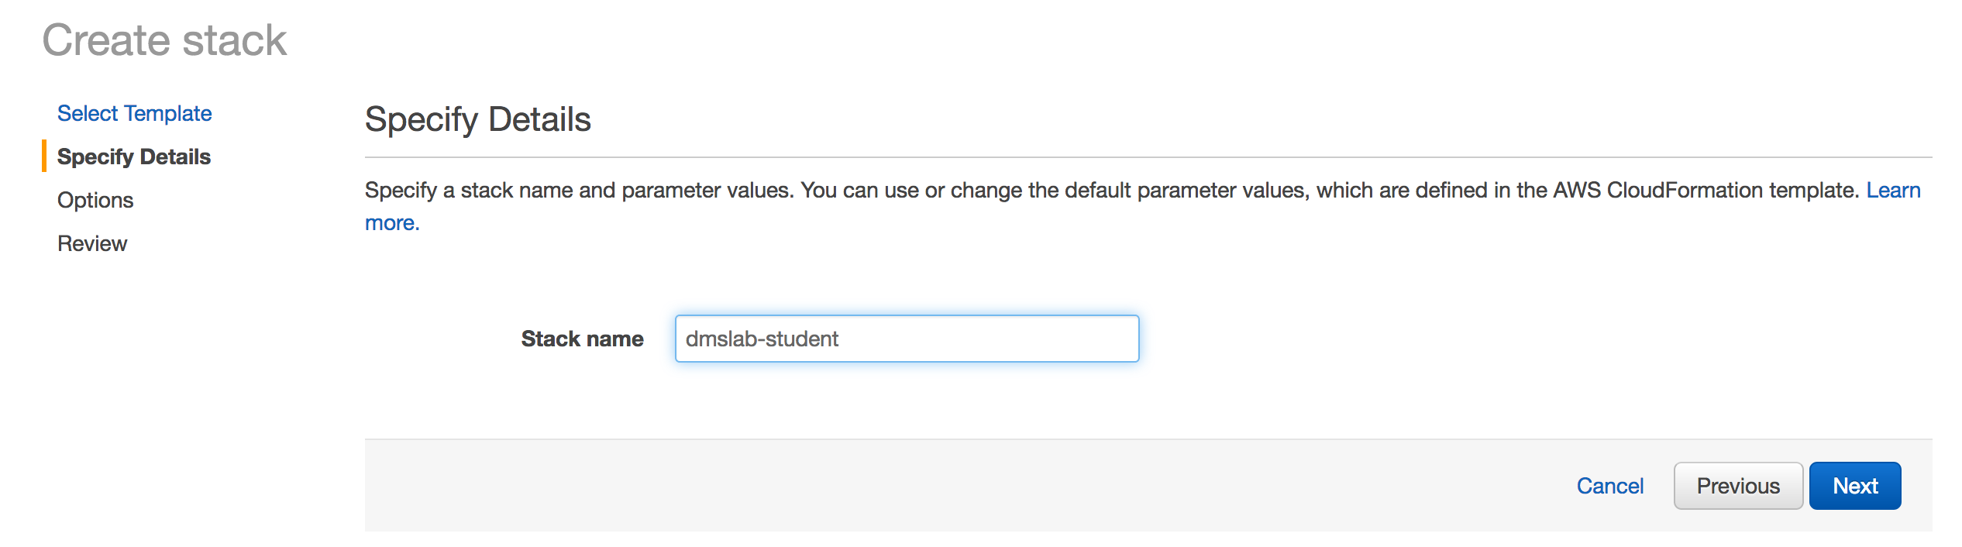

1. Launch the stack. It may take up to 5 minutes for the stack to launch.

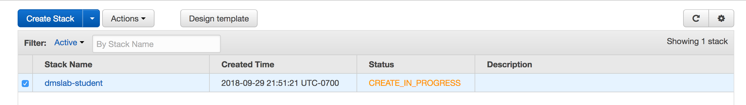

1. Click in the Output tab and take note of value for BucketName , GlueLabRole and DMSLabRoleS3 , which you are going to use in future labs.

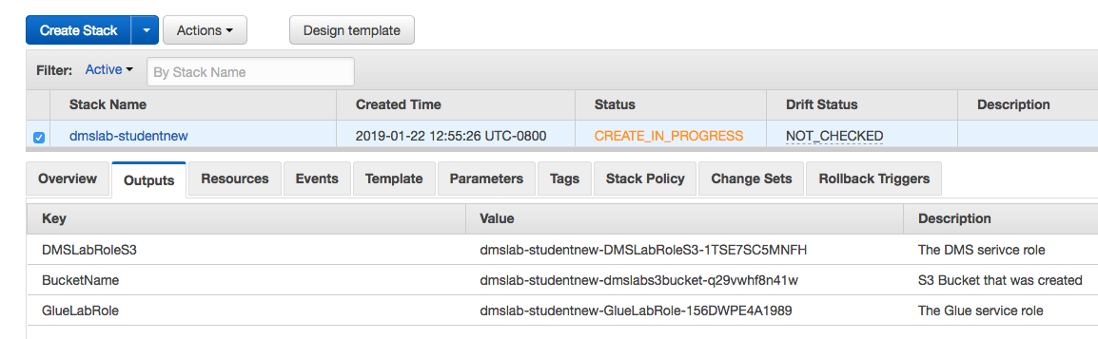

Also take note of resource tab where you have information regarding VPC , Subnet etc.

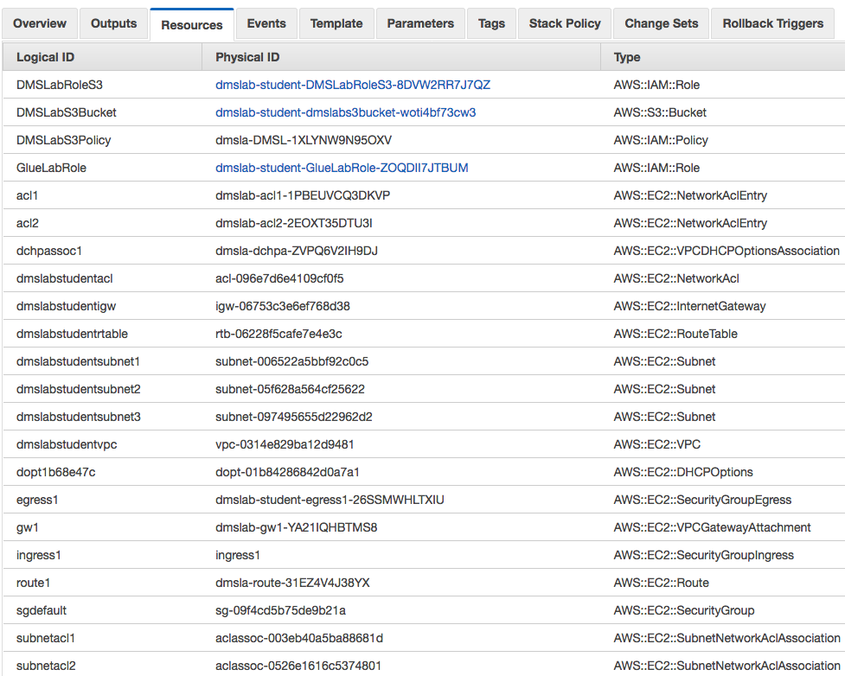

Begin the main AWS DMS lab after the stack is launched.

# Appendix: AWS CloudFormation Template

The AWS CloudFormation template is below. **This template only works in the us-east-1 region.**

Copy and paste this template into a student_dmslab.json file on your computer and save. Select that file in AWS CloudFormation for Step 3.

{

"AWSTemplateFormatVersion": "2010-09-09",

"Outputs": {

"DMSLabRoleS3": {

"Description": "The DMS serivce role",

"Value": {

"Ref": "DMSLabRoleS3"

}

},

"GlueLabRole": {

"Description": "The Glue service role",

"Value": {

"Ref": "GlueLabRole"

}

},

"BucketName" : {

"Description" : "S3 Bucket that was created" ,

"Value" : {

"Ref" : "DMSLabS3Bucket"

}

}

},

"Resources": {

"dmslabstudentvpc": {

"Type": "AWS::EC2::VPC",

"Properties": {

"CidrBlock": "10.0.0.0/24",

"InstanceTenancy": "default",

"EnableDnsSupport": "true",

"EnableDnsHostnames": "false",

"Tags": [

{

"Key": "Name",

"Value": "dmslstudv1"

}

]

}

},

"dmslabstudentsubnet1": {

"Type": "AWS::EC2::Subnet",

"Properties": {

"CidrBlock": "10.0.0.0/26",

"AvailabilityZone": "us-east-1a",

"VpcId": {

"Ref": "dmslabstudentvpc"

},

"Tags": [

{

"Key": "Name",

"Value": "dmslstudv1"

}

]

}

},

"dmslabstudentsubnet2": {

"Type": "AWS::EC2::Subnet",

"Properties": {

"CidrBlock": "10.0.0.128/26",

"AvailabilityZone": "us-east-1c",

"VpcId": {

"Ref": "dmslabstudentvpc"

},

"Tags": [

{

"Key": "Name",

"Value": "dmslstudv1"

}

]

}

},

"dmslabstudentsubnet3": {

"Type": "AWS::EC2::Subnet",

"Properties": {

"CidrBlock": "10.0.0.64/26",

"AvailabilityZone": "us-east-1b",

"VpcId": {

"Ref": "dmslabstudentvpc"

},

"Tags": [

{

"Key": "Name",

"Value": "dmslstudv1"

}

]

}

},

"dmslabstudentigw": {

"Type": "AWS::EC2::InternetGateway",

"Properties": {

"Tags": [

{

"Key": "Name",

"Value": "DMSLab-IGW"

}

]

}

},

"dopt1b68e47c": {

"Type": "AWS::EC2::DHCPOptions",

"Properties": {

"DomainName": "ec2.internal",

"DomainNameServers": [

"AmazonProvidedDNS"

]

}

},

"dmslabstudentacl": {

"Type": "AWS::EC2::NetworkAcl",

"Properties": {

"VpcId": {

"Ref": "dmslabstudentvpc"

}

}

},

"dmslabstudentrtable": {

"Type": "AWS::EC2::RouteTable",

"Properties": {

"VpcId": {

"Ref": "dmslabstudentvpc"

}

}

},

"sgdefault": {

"Type": "AWS::EC2::SecurityGroup",

"Properties": {

"GroupDescription": "default VPC security group",

"VpcId": {

"Ref": "dmslabstudentvpc"

}

}

},

"acl1": {

"Type": "AWS::EC2::NetworkAclEntry",

"Properties": {

"CidrBlock": "0.0.0.0/0",

"Egress": "true",

"Protocol": "-1",

"RuleAction": "allow",

"RuleNumber": "100",

"NetworkAclId": {

"Ref": "dmslabstudentacl"

}

}

},

"acl2": {

"Type": "AWS::EC2::NetworkAclEntry",

"Properties": {

"CidrBlock": "0.0.0.0/0",

"Protocol": "-1",

"RuleAction": "allow",

"RuleNumber": "100",

"NetworkAclId": {

"Ref": "dmslabstudentacl"

}

}

},

"subnetacl1": {

"Type": "AWS::EC2::SubnetNetworkAclAssociation",

"Properties": {

"NetworkAclId": {

"Ref": "dmslabstudentacl"

},

"SubnetId": {

"Ref": "dmslabstudentsubnet3"

}

}

},

"subnetacl2": {

"Type": "AWS::EC2::SubnetNetworkAclAssociation",

"Properties": {

"NetworkAclId": {

"Ref": "dmslabstudentacl"

},

"SubnetId": {

"Ref": "dmslabstudentsubnet1"

}

}

},

"subnetacl3": {

"Type": "AWS::EC2::SubnetNetworkAclAssociation",

"Properties": {

"NetworkAclId": {

"Ref": "dmslabstudentacl"

},

"SubnetId": {

"Ref": "dmslabstudentsubnet2"

}

}

},

"gw1": {

"Type": "AWS::EC2::VPCGatewayAttachment",

"Properties": {

"VpcId": {

"Ref": "dmslabstudentvpc"

},

"InternetGatewayId": {

"Ref": "dmslabstudentigw"

}

}

},

"subnetroute1": {

"Type": "AWS::EC2::SubnetRouteTableAssociation",

"Properties": {

"RouteTableId": {

"Ref": "dmslabstudentrtable"

},

"SubnetId": {

"Ref": "dmslabstudentsubnet1"

}

}

},

"subnetroute3": {

"Type": "AWS::EC2::SubnetRouteTableAssociation",

"Properties": {

"RouteTableId": {

"Ref": "dmslabstudentrtable"

},

"SubnetId": {

"Ref": "dmslabstudentsubnet3"

}

}

},

"subnetroute4": {

"Type": "AWS::EC2::SubnetRouteTableAssociation",

"Properties": {

"RouteTableId": {

"Ref": "dmslabstudentrtable"

},

"SubnetId": {

"Ref": "dmslabstudentsubnet2"

}

}

},

"route1": {

"Type": "AWS::EC2::Route",

"Properties": {

"DestinationCidrBlock": "0.0.0.0/0",

"RouteTableId": {

"Ref": "dmslabstudentrtable"

},

"GatewayId": {

"Ref": "dmslabstudentigw"

}

},

"DependsOn": "gw1"

},

"dchpassoc1": {

"Type": "AWS::EC2::VPCDHCPOptionsAssociation",

"Properties": {

"VpcId": {

"Ref": "dmslabstudentvpc"

},

"DhcpOptionsId": {

"Ref": "dopt1b68e47c"

}

}

},

"ingress1": {

"Type": "AWS::EC2::SecurityGroupIngress",

"Properties": {

"GroupId": {

"Ref": "sgdefault"

},

"IpProtocol": "-1",

"SourceSecurityGroupId": {

"Ref": "sgdefault"

},

"SourceSecurityGroupOwnerId": "105763911922"

}

},

"egress1": {

"Type": "AWS::EC2::SecurityGroupEgress",

"Properties": {

"GroupId": {

"Ref": "sgdefault"

},

"IpProtocol": "-1",

"CidrIp": "0.0.0.0/0"

}

},

"DMSLabS3Bucket": {

"Type": "AWS::S3::Bucket"

},

"DMSLabS3Policy": {

"Type": "AWS::IAM::Policy",

"Properties": {

"PolicyName": "DMSLabS3Policy",

"PolicyDocument": {

"Version": "2012-10-17",

"Statement": [

{

"Effect": "Allow",

"Action": [

"s3:GetObject",

"s3:PutObject",

"s3:DeleteObject"

],

"Resource": [

{

"Fn::Join": [

"",

[

{

"Fn::GetAtt": [

"DMSLabS3Bucket",

"Arn"

]

},

"/*"

]

]

}

]

},

{

"Effect": "Allow",

"Action": [

"s3:ListBucket"

],

"Resource": [

{

"Fn::GetAtt": [

"DMSLabS3Bucket",

"Arn"

]

}

]

}

]

},

"Roles": [

{

"Ref": "DMSLabRoleS3"

},

{

"Ref": "GlueLabRole"

}

]

}

},

"DMSLabRoleS3": {

"Type": "AWS::IAM::Role",

"Properties": {

"AssumeRolePolicyDocument": {

"Version": "2012-10-17",

"Statement": [

{

"Effect": "Allow",

"Principal": {

"Service": [

"dms.amazonaws.com"

]

},

"Action": [

"sts:AssumeRole"

]

}

]

},

"Path": "/"

}

},

"GlueLabRole": {

"Type": "AWS::IAM::Role",

"Properties": {

"AssumeRolePolicyDocument": {

"Version": "2012-10-17",

"Statement": [

{

"Effect": "Allow",

"Principal": {

"Service": [

"glue.amazonaws.com"

]

},

"Action": [

"sts:AssumeRole"

]

}

]

},

"Path": "/service-role/",

"ManagedPolicyArns": [

"arn:aws:iam::aws:policy/service-role/AWSGlueServiceRole"

]

}

}

}

}